7/26/2020 Worship Service

Invocation
Good morning. I am Deacon Ellen and for today’s Prayer of Invocation I will be reading Psalm 105: verses 1 through 11 and verse 45.
God’s Faithfulness to Israel
O give thanks to the Lord, call on his name; make known his deeds among the people. Sing to him, sing praises to him; tell of all his wonderful works. Glory in his holy name; let the hearts of those who seek the Lord rejoice. Seek the Lord and his strength; seek his presence continually. Remember the wonderful works he has done, his miracles, and the judgments he uttered, O offspring of his servant Abraham, children of Jacob, his chosen ones. He is the Lord our God; his judgements are in all the earth. He is mindful of his covenant forever, of the word that he commanded, for a thousand generations, the covenant that he made with Abraham, his sworn promise to Isaac, which he confirmed to Jacob as a statute, to Israel as an everlasting covenant, saying, “To you, I will give the land of Canaan as your portion for an inheritance.”

That they might keep his statutes and observe his laws. Praise the Lord!

Let us now say the words our Lord has taught us:
Our Father, who art in heaven, hallowed be Thy name. Thy kingdom come. Thy will be done on earth as it is in heaven. Give us this day our daily bread. And forgive us our debts as we forgive our debtors. And lead us not into temptation but deliver us from evil. For thine is the kingdom, and the power and the glory forever. Amen.

We come now to our offering as it is through our offering that we identify with Jesus Christ, our Lord. There are several ways that you can make a donation to our church through your financial offerings. You can mail your donation to the church at First Congregational Church in Randolph, 1 South Main Street, Randolph, MA 02368, or you can donate now through our website at www.firstuccrandolph.org. At the bottom of the cover page on our website, you will see a place where you can make your offering. That will bring you to another page where you can follow the prompts that lead you to the donation button. Our morning offering will be gratefully received.
Pastoral Prayer
Loving Creator God, we come to worship lonely or empty or frightened. We come to worship sick or grieving or discouraged. We come from households where there is anger. We come from unfinished projects, ruined plans, multiple irritations. We turn away from news and local opportunities to help someone.
God of blessing and God of our most difficult times, we come to you for a moment of quiet in our busyness. We come to you for energy in our weariness. We long for the peace of your presence, even as we are afraid of the urgency of your call. God of comfort and peace, do not leave us in the events to come.
Holding fast to the assurance of our forgiveness through the risen Christ, we come to you this morning with our concerns and our requests.
We have concerns for people who are hungry. We have concerns for people who are homeless, abused, sick, confused, addicted, lonely or lost. We have concerns about people who are worried about loved ones, or grieving for those who have passed over.
We have concerns we have shared with each other and we know that you listen to each one.
We pray for ourselves today, Lord. We have concerns about money. We have concerns about health. We have concerns about relationships. We have doubts and fears. We miss our loved ones and friends who have gone home to you, even though we know we will be with them again.
And Lord some of us have concerns we keep quietly to ourselves. We know that you hear the yearnings of our hearts.
We invite your Holy Spirit into our hearts. Help us with your Spirit to trust you. Give us the strength to bear the things we must. Help us with your Spirit to be thankful and to praise you. Encourage us to ask you for forgiveness, knowing that Jesus has paved the way for us. Give us the humility to ask each other for forgiveness. And then teach us to forgive, especially in those situations where it is so hard to do. Help us to share what we have and help us to set aside our pride when we need to ask for help. Help us to “weep with those who weep and rejoice with those who rejoice.” Make us a true family united by your love.
Show us what we can do, for ourselves, and for others. Where it is appropriate, change our concern into action. Give us the courage to say and do the things you want us to say and do. Help us to be peacemakers and healers wherever we find ourselves.
And those things we cannot or should not fix, we place them all before you now, Lord. We release them. We give them to you. And we ask for your peace to gently fall on us. We ask all this boldly and confidently in the name of your son, Jesus, Amen.
Scripture
The scripture reading of the Old Testament is Genesis 29, verses 15 through 28: Jacob Marries Laban’s Daughters.
15 Then Laban said to Jacob, “Because you are my kinsman, should you therefore serve me for nothing? Tell me, what shall your wages be?” 16 Now Laban had two daughters; the name of the elder was Leah, and the name of the younger was Rachel. 17 Leah’s eyes were lovely,[a] and Rachel was graceful and beautiful. 18 Jacob loved Rachel; so he said, “I will serve you seven years for your younger daughter Rachel.” 19 Laban said, “It is better that I give her to you than that I should give her to any other man; stay with me.” 20 So Jacob served seven years for Rachel, and they seemed to him but a few days because of the love he had for her.
21 Then Jacob said to Laban, “Give me my wife that I may go in to her, for my time is completed.” 22 So Laban gathered together all the people of the place, and made a feast. 23 But in the evening he took his daughter Leah and brought her to Jacob; and he went in to her. 24 (Laban gave his maid Zilpah to his daughter Leah to be her maid.) 25 When morning came, it was Leah! And Jacob said to Laban, “What is this you have done to me? Did I not serve with you for Rachel? Why then have you deceived me?” 26 Laban said, “This is not done in our country—giving the younger before the firstborn. 27 Complete the week of this one, and we will give you the other also in return for serving me another seven years.” 28 Jacob did so, and completed her week; then Laban gave him his daughter Rachel as a wife.
And the New Testament is Romans 8, verses 26 through 39
26 Likewise the Spirit helps us in our weakness; for we do not know how to pray as we ought, but that very Spirit intercedes[a] with sighs too deep for words. 27 And God,[b] who searches the heart, knows what is the mind of the Spirit, because the Spirit[c] intercedes for the saints according to the will of God.[d]
28 We know that all things work together for good[e] for those who love God, who are called according to his purpose. 29 For those whom he foreknew he also predestined to be conformed to the image of his Son, in order that he might be the firstborn within a large family.[f] 30 And those whom he predestined he also called; and those whom he called he also justified; and those whom he justified he also glorified.
31 What then are we to say about these things? If God is for us, who is against us? 32 He who did not withhold his own Son, but gave him up for all of us, will he not with him also give us everything else? 33 Who will bring any charge against God’s elect? It is God who justifies. 34 Who is to condemn? It is Christ Jesus, who died, yes, who was raised, who is at the right hand of God, who indeed intercedes for us.[g] 35 Who will separate us from the love of Christ? Will hardship, or distress, or persecution, or famine, or nakedness, or peril, or sword? 36 As it is written,
“For your sake we are being killed all day long;
we are accounted as sheep to be slaughtered.”
37 No, in all these things we are more than conquerors through him who loved us. 38 For I am convinced that neither death, nor life, nor angels, nor rulers, nor things present, nor things to come, nor powers, 39 nor height, nor depth, nor anything else in all creation, will be able to separate us from the love of God in Christ Jesus our Lord.
So be the words spoken.
Sermon
May the words of my mouth and the meditation of our hearts be acceptable in Thy sight, O Lord our Rock and our Redeemer. Amen.
Before we begin, I will offer a trigger warning. We will be discussing beatings, slavery, briefly rape and execution. If you need to stop watching, now or at any time, please do so with our prayers, our blessing and our love.
The first theme suggested by our Epistle lesson this morning is separation. We are all experiencing separation in various forms. Some of us are separated from our friends. Some of us are separated from our children, our parents, our grandchildren, our grandparents or other relatives. Some of us are separated from our spouse, especially painful if our spouse is in the hospital for any reason. Students may be separated from their teachers, and teachers may long for in-person time with their students. Some employees are separated from their jobs and their income, and those fortunate enough to be able to work from home are separated from their co-workers and their clients. We are separated from our church brothers and sisters, although thankfully we have the technology to permit us to worship together like this. And although some may say it is more trivial, the mental health impact is real that we are separated from our favorite restaurants, our favorite places, spectator sports and participant sports. If we read the news, some of us may be feeling a separation from our ideals of what our country should be like.
In the Apostle Paul’s Letter to the churches in Rome, he talks about some things which might tend to separate us from God’s love.
Paul was born about the same time as Jesus, but never met him in the flesh. Paul was an educated Hellenistic Jew, who grew up in The City of Tarsus, in what today is the southeastern corner of Turkey. He was very articulate in Greek, which was the common language of the time, and he was a Pharisee, studying the Hebrew Scriptures in Jerusalem. He thoroughly knew his Bible, which was at that time the Hebrew Scriptures, what we sometimes call the Old Testament. The Christian Scriptures were not fully written yet, not gathered into what we call the New Testament, partly because Paul had been busy writing half of them himself.

Paul began as a persecutor of the early Christians. His encounter with the Risen Christ changed all that, and he became the primary apologist of the new religion. He did not see it as a new religion, but as a continuation of the relationship of the Children of Israel with the God of Abraham, Isaac and Jacob. Paul retained his Jewish faith, although he perceived his role as bringing the new understandings of faith mostly to the Gentiles – meaning all who were not Jewish.

Paul wrote this letter to the new congregations of Christians in Rome. Their origin is obscure. Paul had not been to Rome himself yet, but was planning a trip there. In today’s lesson, he reassures us with the message that nothing can come between us and the love of God.
His first expression of this deals with things which Paul himself had experienced or feared he would. He had enemies from two sides: religious Jews opposed the new religion, as Paul himself had originally, and his safety might have been in jeopardy wherever he went. And the Roman Empire, when confronted with his preaching, felt a threat to the worship of the Emperor.
Paul says “Who will separate us from the love of Christ? Will hardship, or distress, or persecution, or famine, or nakedness, or peril, or sword?” We ourselves today are facing hardships, persecution, hunger, danger from guns. Paul immediately answers “No, in all these things we are more than conquerors through him who loved us.”
Nine days ago a beloved civil rights leader passed over to the other side after battling cancer. John Lewis knew about hardship, persecution, peril. He received beatings for leading black people asking for their rights. In 1961, at the age of 21, John Lewis joined the Freedom Riders in Alabama, riding public transportation to integrate bus travel. He helped organize the 1963 March on Washington, and was its youngest speaker. In 1965, working for voting rights, he was a leader of the Edmund Pettis Bridge demonstration, where an Alabama State Policeman beat him with a club and fractured his skull. He was arrested more than 45 times, for what he called “good trouble.” He went on to a political career, serving over 30 years in Congress and earning the Presidential Medal of Freedom.
Hardship, persecution, peril, billy clubs did not separate John Lewis from the love of God. To the end he was cheerful. This year he said “Yes, I was beaten, left bloody and unconscious. But I never became bitter or hostile, never gave up. I believe that somehow and some way if it becomes necessary to use our bodies to help redeem the soul of a nation, then we must do it.”
The Apostle Paul understood all this, more than 19 centuries ago. He wrote his letter to the Romans in the year 58 of the current era, and two years later, under the persecution of the Roman Emperor Nero, he was beheaded in Rome.
More than just physical threats, Paul knew that nothing, even death, could separate him from the love of God. He says “… neither death, nor life, nor angels, nor rulers” – he means here spirit world rulers – “nor things present, nor things to come, nor powers, nor height, nor depth, nor anything else in all creation, will be able to separate us from the love of God in Christ Jesus our Lord.”
Let’s talk about just a couple of those things.
Paul says that death cannot separate us from the love of God. There are two things I would suggest that we consider about death.
Firstly, and I will not sugarcoat this for you, we all know, but we try not to think about, the fact that each of us will die someday. If I think every day, “Well I’m not going to die today,” and that helps me get through the day, I think that’s fine. But when my time comes, slowly or suddenly it will become a runaway train, and I will be powerless to stop it. That is normal, that is natural.
The second thing about death I suggest we contemplate is this. There is a saying that “Everyone wants to go to heaven, but nobody wants to die.” My friends, that is how we get there! It is how we get to be in the more immediate presence of our loving God, and on the other side we will bask in the warmth of God’s love forever.
Paul also tells us that life cannot separate us from the love of God. This is even happier news. Our dying and eternal bliss will take care of themselves, but while we are still here, this life can be awfully distracting and, these days it seems, often depressing.
Paul calls us away from the distractions of this world to remember that no matter what happens, God is right here with us. To Paul, God’s love is the ultimate security. The Holy Spirit, living in our hearts, gets us through whatever life throws at us.
And let’s remember that good things, too, can distract us, from remembering God’s love for us and from sharing God’s love with others.
Faith in the midst of tribulation, faith in the midst of good times. The key is to remember God’s love every day, every minute of every day.

Now that we have been reminded of our happy existence as God’s beloveds, let’s take a look at the Scripture lesson in Genesis and see what suggestions it has for us today.
The Hebrew Scriptures tell us the story of the relationship of the God of Abraham, Isaac and Jacob with the Children of Israel. Israel and Jacob are the same person, and today’s Scripture lesson tells us about the beginning of Jacob’s family.
One of the things I admire about the Hebrew Scriptures is their candor. God through the ages is constant, but God’s people are quintessentially human. That’s why we can learn about ourselves from the stories – the human imperfections are left in for us to read about.
Jacob has cheated his older brother Esau out of his birthright and their father’s blessing. That’s a story for another time. But now Jacob has run away from his brother’ anger and arrived at his uncle Laban’s territory. For the next 20 years Laban will cheat his nephew in several different ways. Today’s Scripture lesson tells of one of them.
Jacob falls in love with Laban’s daughter Rachel, and because he has arrived empty-handed, he has nothing to give for her. He offers to work for his uncle for seven years, and Laban agrees.
Before we go any further, let me mention that we will be discussing slavery as part of the story. Slavery pervaded life throughout Mesopotamia. The Code of Hammurabi and other codes contained many laws specifying the buying, selling and treatment of slaves. Slavery was an accepted practice in various forms up to and including the time of Jesus, thousands of years later. But nothing I am about to say should be construed as condoning slavery in any way.
Jacob works for his Uncle Laban for seven years. This is actually one form of slavery, and centuries later is codified in the TORAH. An Israelite could indenture himself to pay off a debt, but was subject to the seven-year and fifty-year jubilees which freed him.
Jacob goes to his uncle and says “OK, I’ve worked for you for seven years. Please give me my bride Rachel.” Laban orders a feast, and on the wedding night switches daughter Leah for Rachel. Jacob, perhaps hampered by darkness and excessive drinking, consummates the marriage.
In the morning, Jacob discovers the swindle, and confronts Laban, who simply says “we don’t do it that way here. The older daughter must be married first.” And then, since he has learned that God has made him a richer man through the good work of Jacob, Laban offers Jacob a new deal.
“Tell you what I’m gonna do,” he says, “you’ll finish out the week of your marriage to Leah. After that, I’ll give you Rachel as your second wife, and, then you’ll work for me another seven years. OK?”
Jacob does not have much choice in the matter, and with marriage to Rachel, the woman he loves, dangled in front of him only a week away, he agrees. “Deal,” he says.
Thus begins the saga of the Children of Israel, that is, the children of Jacob, starting with a very disfunctional family. The 2 sisters resent each other. Leah, despite bearing 7 children for her husband, spends the rest of her life feeling unloved by her husband. Rachel spends most of her life grieving over her inability to conceive, and finally bears 2 children for Jacob, dying in childbirth.
And it gets worse. If you were counting, that only accounts for 9 of the 13 children. The Children of Israel comprises 12 tribes from 12 sons.
One verse of this morning’s lesson says that Laban gave his maid Zilpah to his daughter Leah to be her maid. This was a common Mesopotamian custom. And in the verse after the lesson, which we did not hear this morning, Laban gives his maid Bilhah to his daughter Rachel to be her maid.
“Maid” is a nice word, hiding an ugly truth. These 2 women are slaves. When Rachel fails to conceive after Leah has had 4 sons, she gives her slave Bilhah to Jacob to serve in her stead, and Bilhah gives Jacob 2 sons on behalf of Rachel. Not to be outdone, Leah then gives her slave Zilpah to Jacob to serve in her stead, and Zilpah gives Jacob 2 sons on behalf of Leah. That accounts for the other 4 sons.
If all this is confusing, I sympathize, but I’m trying to make a point. Take a look at this chart I made.
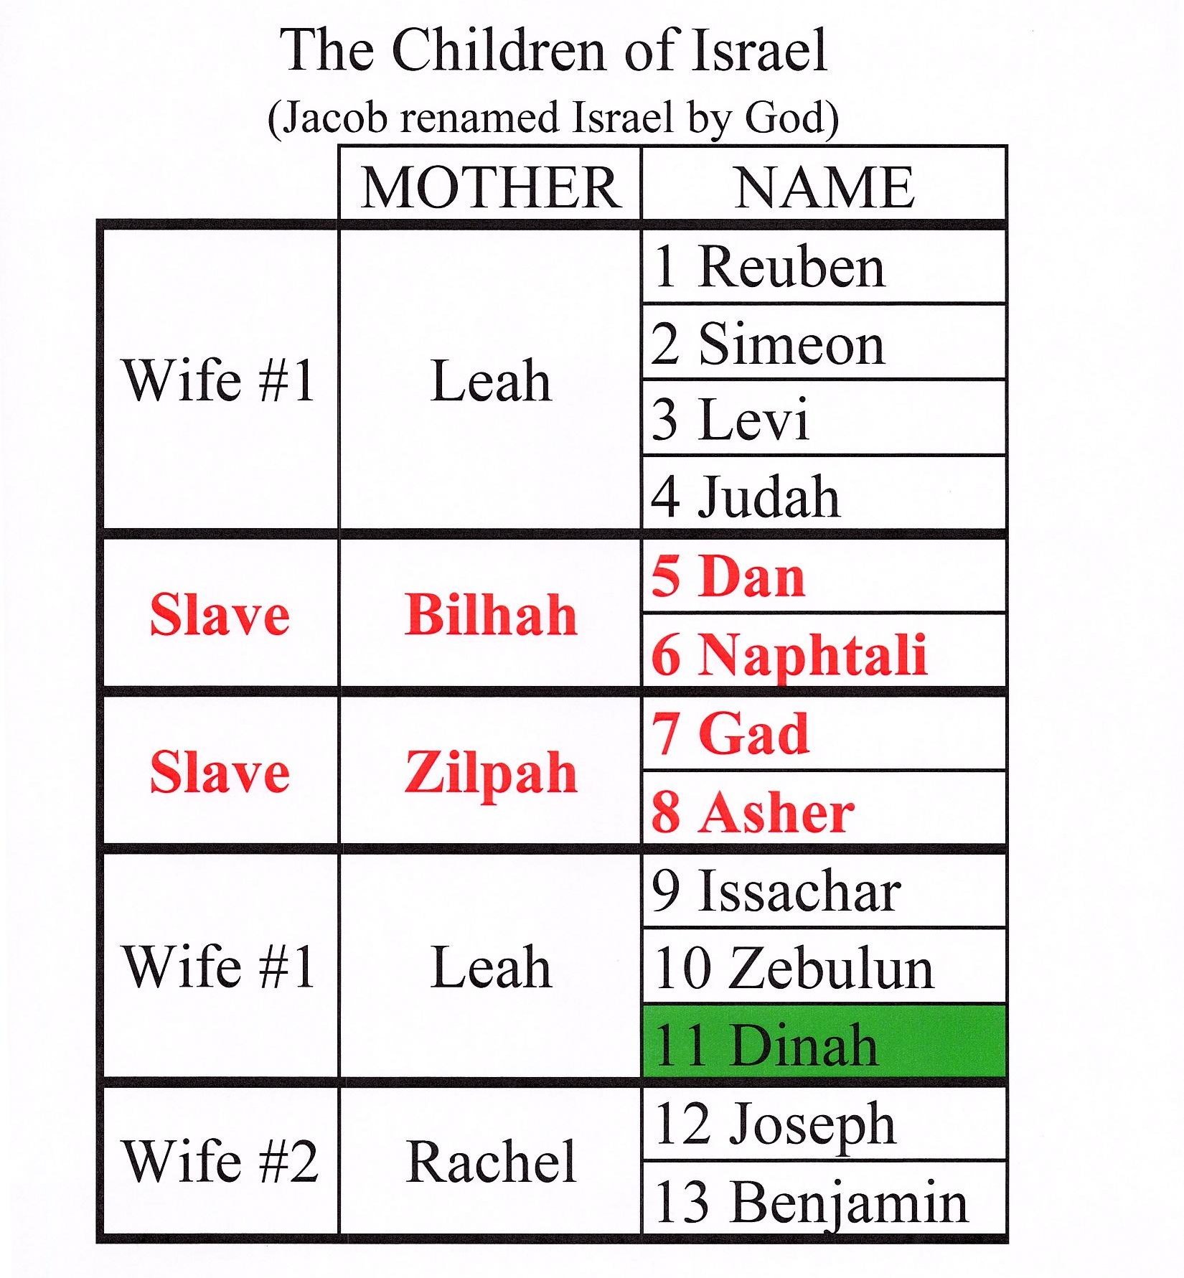
The column on the right is the Children of Jacob, listed in order of birth. The middle column is the name of the mother, and the left column is her status.
All I want to highlight here is that in the case of 4 of the 12 tribes, the mother was a slave.
Years later, Joseph is sold into slavery by his older brothers, and they tell Jacob that his son, at that time the only son of his beloved Rachel, is dead. A caravan of merchants takes Joseph to Egypt and sells him. Joseph becomes favored by the pharaoh, ultimately invites his family to come to Egypt during a famine, and is reunited with his family. The Children of Israel, all 12 tribes, moves to Egypt where they are fed and given the Land of Goshen.
I’ll mention here that the treatment of all women is not much better than that of slaves. Leah and Rachel are not reported to have been consulted about their marriages. Dinah, the only daughter of Jacob, because she is a girl-child, receives no inheritance, and disappears from the record. None of these women has a voice. But that is a topic for another sermon.
The Children of Israel thrive in Goshen. The Egyptian people resent them and envy their prosperity. After a few generations, the Egyptians enslave the entire nation. They put them in their homes as servants, they put them to work in the fields, they add them to the many slaves constructing large buildings. All Israelites are born into slavery. After generations of suffering Moses comes along and, with the power of God, liberates them and the entire nation leaves Egypt in the Exodus.
Resentment and envy are ugly passions. In 1921, only 99 years ago, a railroad track ran through the center of the City of Tulsa, Oklahoma. On one side of the tracks lived the white residents of Tulsa. On the other side lived the black citizens. The black folk were prospering. They had successful businesses. They had nice houses, nice furniture, nice automobiles. The white people of Tulsa resented the prosperity of their fellows, and envied their wealth. So they burned down the black-owned businesses, burned down their houses and killed an estimated 300 black people.

Some of us are biological descendants of slaves. All of us are spiritual descendants of the Children of Israel. They gave us Great King David, his son King Solomon, Paul the Apostle and Jesus of Nazareth. Whoever we encounter each day, we might ask ourselves if this person might be, one way or another, a descendant of a slave. And with that common bond, we might feel a kinship, whether that person is standing in the street holding a sign asking for justice, or a policeman standing in the street, who became a cop to protect people, or our next door neighbor.

God loves you. God loves each and every one of us, and like a parent who loves all her children, God wants us to love each other. Nothing can separate us from the love of God, and knowing that we can answer the call to share that love with everyone we meet.
Amen.

Benediction
The benediction I chose was “In This Very Room” because I felt everybody is in their own little room.
In this very room, there’s quite enough love
In this very room, there’s quite enough joy
And there’s quite enough hope and quite enough power to chase away any gloom
For Jesus, Lord Jesus, is in this very room.

Have a good week and stay safe.

