FIRST CONGREGATIONAL CHURCH
of RANDOLPH
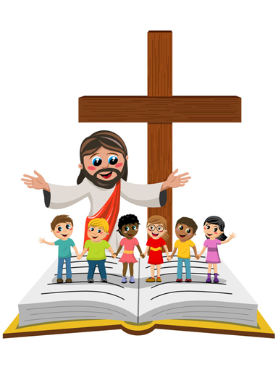
SUNDAY SCHOOL PROGRAM

Dreamstime.com
FIRST CONGREGATIONAL CHURCH of RANDOLPH
1 S. Main St., Randolph, MA 02368 * 781 – 963 – 6373
FirstUccRandolph19@gmail.com
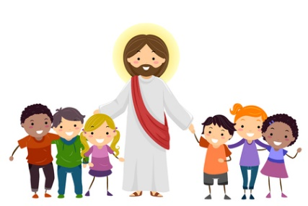
Shutterstock.com
SUNDAY SCHOOL PROGRAM
This Christian Education Program celebrates the presence of the children in church by offering a colorful & educational Sunday School workbook curriculum, inviting them to participate in the worship services such as hearing the Children’s Message on the altar steps once a month, occasionally light the altar candles, march down the aisle in the Palm Sunday Procession, making art & crafts, receive special occasion gifts, and receive a balloon for his or her birthday. All because Jesus said, “Let the children come to me.” Mark 10:13 – 16
It all starts with:
* Rally Day on the 2nd Sunday of September to start the new school
year with a festive and meaningful theme.
* Pumpkin Carving Party to shine the light of Jesus.
* Thanksgiving Food Bags – Draw and color hand-traced turkeys on
paper grocery bags for non-perishable Thanksgiving food
donations to give to the Randolph Food Pantry.
* Christmas Advent ~ Light Advent candles in the chapel
~ Receive battery-powered candles ~ Make Christmas crafts
~ Make Christmas cards for the elderly &/or the U.S. soldiers
~ Bring donated Toys for Tots toys to the Randolph Fire Station
~ Do Random Acts of Christmas Kindness (R.A.C.K.) by giving small
Christmas goody bags with a little Christmas message to the
customers at Shaw’s (with parents’ permission)
~ Sing Christmas Carols to the Seth Mann House residents on
North Main Street (with parents’ permission)
~ Nativity Pageant
iStock.com

* Souper Bowl Soup Collection – In church on the NFL Super Bowl
Sunday (February), children wear fabric football helmets and collect
canned soups with big pots during worship service as a fun Souper
Bowl event for the Randolph Food Pantry.
* Lent Activities – Meaningful and fun activities each Sunday during Lent
to prepare for Easter.
* Mother’s Day – During church, children give all the women a flower and
children make special crafts for their mothers.
* Children’s Sunday – On the 2nd Sunday of June, the children participate
in the whole worship service with the assistance of the Christian
Education Committee, the Sunday School teachers and the Music
Director. Children who graduate 2nd grade will receive a NIV Children’s
Bible.
* Father’s Day – During church, children give all the men a flower and
children make special crafts for their fathers.
These are the traditional activities that take place in the Sunday School program throughout the year although they may change.
The Sunday School program is for children in Preschool – Grade 7.
Confirmation classes are offered for 8th graders & up.
A Nursery Program is available for the wee little children.
Church Scholarships applications are available in May for college-bound High School seniors who have been active in church for 2 years.
There are two Sunday School teachers and a Teacher Aide (when available) in each classroom. The Sunday School staff and the Nursery staff are all CORI (Criminal Offender Record Information) checked.
The Christian Education Committee consists of a C.E. Director, C.E. Chairperson(s), and up to 6 C.E. Committee members who meet once a month to discuss and plan activities and events.
Some of the activities listed in this brochure are limited due to the COVID-19 pandemic at this time.
The Church Nursery is not open due to the COVID-19 pandemic at this time.

The activities and events have been modified to make them possible to be done right from your home!

Participation in some of the special church events can be videotaped by the parents or the Music Director who is very experienced in videography and he is available on certain days in church. The videos will be posted on the church’s Facebook page with the parents’ permission.
The Sunday School lessons and crafts packets will be delivered to the children’s homes every Sunday morning by a member of the C.E. Committee who will put them in your front door or
in your mailbox and she will text you that the Sunday School packet has arrived.
With Blessings,
Carla Provost
Christian Education Director
8/29/21

